# Implementing PSO using Lookup Table:-

Pmpp = 180 W

Voc=43.64

Isc=5.45

Vmp=36.36

Imp=4.95

Dmpp = 0.88 (calculated from Lookup Table and assuming Rload)

Step 1: lookup Table is generated

for V = 0.1 to V = 43.6,

I is calculated using IV curve.

Hence, Effective R is calculated for every point.

Step 2: Considering Boost Convertor,

Reff = Rload * (1-d)2

Rload is chosen as 500 Ω.

Step 3: Power vs duty curve is also plotted using above formula (taking Rload =500 Ω).

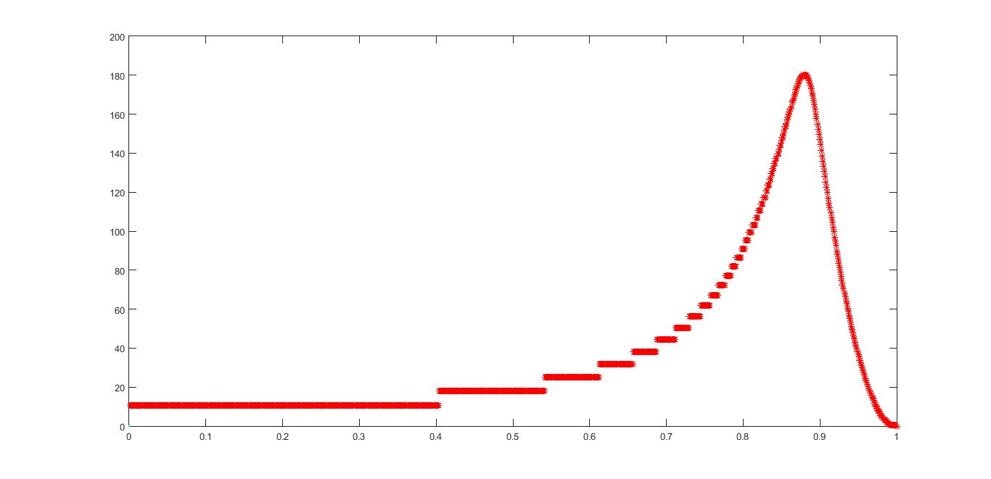

For PSO ::

Pk+1 = Pk + Vk

VK+1 = w*Vk + c1*r*(Pl - Pk) + c2*r*(Pg - Pk)

***Simulation 1 ::***

Variables => w=0.1

C1 = 0.2

C2 = 0.2

R = 0.4

Particles => D1 = 0.40 (both side of dmax)

D2 = 0.60

D3 = 0.95

Result :: Particles converges (within 2% of Pmpp) after 43rd Iteration.

***Simulation 2::***

Variables => w=0.1

C1 = 0.2

C2 = 0.2

R = 0.4

Particles => D1 = 0.40 (Same side of dmax)

D2 = 0.60

D3 = 0.80

Result :: failed to converge even after 50 iterations (Pmax reached = 91W)

***Simulation 3::***

Variables => w=0.5 (improved Parameter values)

C1 = 0.5

C2 = 0.5

R = 0.5

Particles => D1 = 0.40 (Same side of dmax)

D2 = 0.60

D3 = 0.80

Result :: failed to converge even after 50 iterations (Pmax reached = 139.6W, Velocity is very small).

***Simulation 4::***

Variables => w=0.5

C1 = 0.5

C2 = 0.5

R = 5 (made x10 from the last simulation)

Particles => D1 = 0.40 (Same side of dmax)

D2 = 0.60

D3 = 0.80

Result :: failed to converge even after 50 iterations (Same Result as last Simulation)

***Simulation 5::***

Variables => w=0.9 (High Value of W)

C1 = 0.5

C2 = 0.5

R = 5

Particles => D1 = 0.40 (Same side of dmax)

D2 = 0.60

D3 = 0.80

Result :: Particles got MPP in 11 iterations but keep oscillating around Mpp with big variations

***Simulation 6::***

Variables => w=0.9 (High Value)

C1 = 0.5

C2 = 0.5

R = 1 (Moderate Value)

Particles => D1 = 0.40 (Same side of dmax)

D2 = 0.60

D3 = 0.80

Result :: got MPP in 8 iterations. Failed to converge but oscillations are not large (about 10% of Pmpp . May be useful with Shifting MPP).

***Simulation 7::***

Variables => w=0.5

C1 = 0.5

C2 = 0.5

R = 1 (moderate value)

Particles => D1 = 0.40 (both side of dmax)

D2 = 0.60

D3 = 0.95

Result :: converges in 10 iterations. Remain at MPP for next iterations (static)

***Simulation 8::***

* ***Test 1***

Variables => w=0.5

C1 = 0.5

C2 = 0.5

R = 1

Particles => D1 = 0.91 (chosen Randomly)

D2 = 0.18

D3 = 0.26

Result :: got MPP in 7 Iterations and all converges in 10 iterations

* ***Test 2***

Variables => w=0.5

C1 = 0.5

C2 = 0.5

R = 1

Particles => D1 = 0.579 (chosen Randomly)

D2 = 0.549

D3 = 0.144

Result :: failed to find MPP. All got converge in local minima(long flat portion of P-d curve)

* ***Test 3,4,5… only 50-60% chances of convergence at MPP (always converges at local points)***

***Simulation 9::***

***Test 1***

Variables => w=0.5

C1 = random

C2 = random

R = 1 (moderate value)

Particles => D1 = 0.69 (All random)

D2 = 0.58

D3 = 0.81

Result :: converges in 8 iterations… got MPP in 11 iterations…(remain closely converged)

***Test 2***

Variables => w=0.5

C1 = random

C2 = random

R = 1 (moderate value)

Particles => D1 = 0.756 (All random)

D2 = 0.555

D3 = 0.898

Result :: got MPP in 3rd iteration and converges in 10 iterations…(remain closely converged)

***Test 3***

Variables => w=0.5

C1 = random

C2 = random

R = 1 (moderate value)

Particles => D1 = 0.64 (All random)

D2 = 0.74

D3 = 0.43

Result :: trapped in local max…

***Test 4***

Variables => w=0.5

C1 = random

C2 = random

R = 1 (moderate value)

Particles => D1 = 0.16 (All random)

D2 = 0.75

D3 = 0.87

Result :: got MPP in 6th iteration and converges in 11 iterations…(remain closely converged)

***Test 5***

Variables => w=0.5

C1 = random

C2 = random

R = 1 (moderate value)

Particles => D1 = 0.57 (All random)

D2 = 0.17

D3 = 0.95

Result :: got MPP in 7th iteration and converges in 13 iterations…(remain closely converged)

***Test 6***

Variables => w=0.5

C1 = random

C2 = random

R = 1 (moderate value)

Particles => D1 = 0.76 (All random)

D2 = 0.93

D3 = 0.10

Result :: got MPP in 9th iteration and converges in 13 iterations…(remain closely converged)

***Test 7***

Variables => w=0.5

C1 = random

C2 = random

R = 1 (moderate value)

Particles => D1 = 0.12 (All random)

D2 = 0.26

D3 = 0.25

Result :: trapped at local MPP